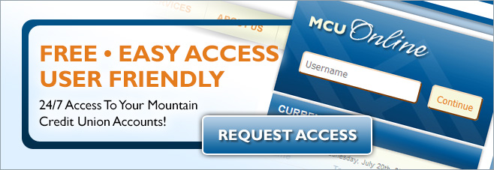

Request Access to MCU Online
Email Your Name & Phone Number to:

marketing@mountaincu.org

A Mountain CU Representative Will Contact You As Soon As Possible!

